APPLICATION FOR CANADIAN REGISTRATION NUMBER (CRN)
CRN认证询价申请表
尊敬的客户：
感谢您的咨询，为了快速、准确地给您提供报价和认证方案，烦请认真填写以下表格中的信息。如果您需要帮助，请联系我们，我们将竭诚为您服务。谢谢您的配合！

Part A申请公司基本信息
申请认证公司名称
公司地址
联系人/部门和职务
联系电话/手机/
电子邮件和公司网址
生产工厂公司名称
工厂地址
工厂员工人数
其它需要说明的事项 | 如果申请公司与持证公司不同，请在此说明！

Part B产品信息及注册要求
Please indicate the type of design请勾选设计的类型
新设计New ☐ |  |  | 修改 Addition/ Revision ☐ |  | 更新Renewal (Only Fitting Registrations) ☐
Please indicate the product type请勾选产品类别
锅炉Boiler ☐ | 压力容器pressure vessel ☐ |  |  | 换热器Heat Exchanger ☐ |  |  | 配件Fitting ☐
Product parameter 产品参数
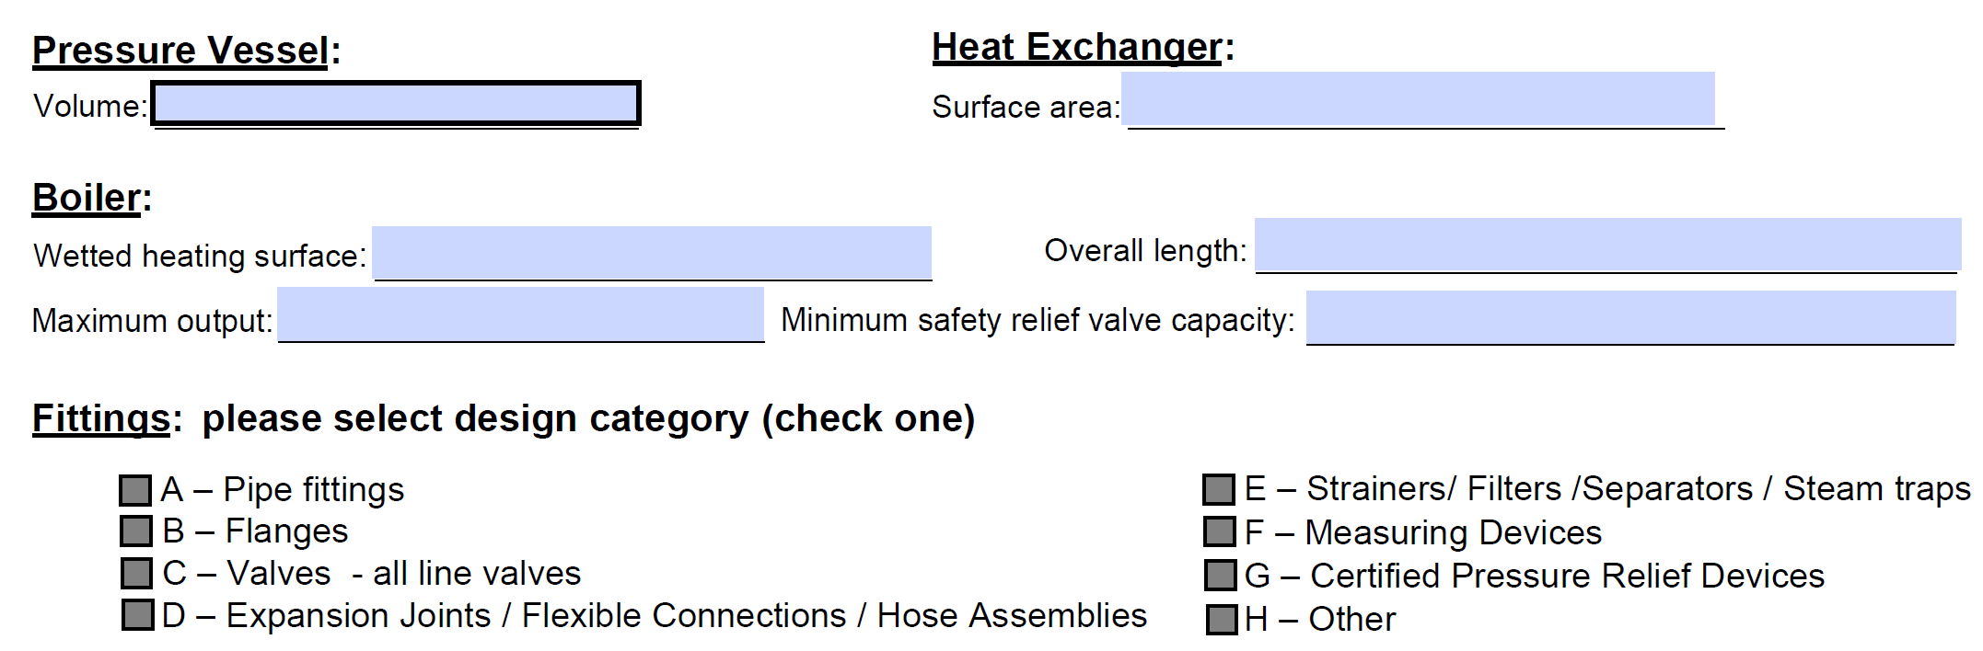
请参考上方不同产品的主要参数要求，并在详细描述在下方：

Registration is requested for要求注册的省份
☐ British Columbia (BC) ☐ Manitoba (MB) ☐ New Brunswick (NB)* ☐ Newfoundland and Labrador (NL)*
☐ Alberta (AB) ☐ Ontario (ON) ☐ Nova Scotia (NS)* ☐ Yukon (YT)* ☐ Northwest Territories (NT)*
☐ Saskatchewan (SK) ☐ Quebec (QC) ☐ Prince Edward Island (PE)* ☐ Nunavut (NU)* ☐ others (pls. specify)
☐ All Jurisdictions (all of Canada)
Please select code/standard of design: (check one or more as applicable) 请选择适合的设计标准
☐ ASME Section I  ☐ ASME Section IV  ☐ ASME PVHO-1 |  | ☐ ASME Section VIII, Division 1  ☐ ASME Section VIII, Division 2  ☐ ASME Section VIII, Division 3 |  |  |  | ☐ ASME B31.1  ☐ ASME B31.3  ☐ ASME B31.5
☐ Other (specify):
Year of code edition:
☆本人在此同意I hereby consent：
此申请表同时作为认证的最终证书确认单，请仔细核对申请者的名称、产品信息等，确认无误后签字盖章。
此内容为报告和证书签发的重要依据，签字确认后，如再更改报告和证书产生的额外费用将由申请方自己承担。
请确保提供的所有资料内容准确。如果因为申请方提供的资料不一致造成的错误而产生的一切费用，由申请方承担。
Note: This application form information is very important, please check the applicant's name, address, product information carefully, sign and seal after confirmation. We will issue the report and certificate based on the application form. The applicant should be responsible for any change of test report and certificate after signed the application form. Please ensure that all the documents provided by the applicant are consistent.

备注Note:
裕洵会在证书签发之前发一份最终确认函给您确认。Yuxun will send you the certificate draft for final confirmation before issuing certificate.

申请方/Applicant：
负责人姓名/Name：
签字和盖章/Sign & Seal：
日期/Date：

